Qualitative Coding and Coding Schemes
- Dimension definitions
Table: Main analytical dimensions
Analytical dimension | Possible subcodes to be developed | What to examine in the text
1. Problem representation | Assumptions about urban safety; construction of governance needs | How urban safety is constructed as a problem, and what assumptions make this representation plausible?
- Governance subject construction | Attributed references and capacities; assigned responsibilities; civic roles; expected forms of participation | What are couriers expected or enabled to do, and how are these expectations legitimised?
3. Discursive silences | Marginalised actors; underrepresented structural conditions; omitted responsibilities; alternative problem definitions | What is backgrounded or left unexamined in relation to the problems foregrounded in the reports?

The qualitative analysis was guided by Bacchi’s (2009) What’s the Problem Represented to Be (WPR) approach. Rather than treating media reports as neutral accounts of urban safety, the analysis examined how these reports discursively constructed urban safety as a governable problem and positioned food delivery couriers in relation to its governance. Three analytical dimensions were developed from WPR Questions 1, 2, 4, and 5: problem representation, governance subject construction, and discursive silences.

The first dimension, problem representation, addressed WPR Questions 1 and 2. Coding examined how urban safety was defined as a problem, which conditions were foregrounded as requiring intervention, and what assumptions underpinned these representations. Particular attention was paid to how the identification of risks, and the perceived need for governance were connected in the reports. The analysis sought to establish how particular constructions of urban safety made certain forms of intervention and courier participation appear necessary or legitimate.

The second dimension, ‘governance subject construction’, drew on WPR Question 5. This dimension examined how food delivery couriers were represented through the attribution of particular capacities, responsibilities, and civic roles. Coding attended to the references attributed to couriers, the obligations imposed on them, and the forms of participation through which they were positioned in urban governance. Subcodes were developed to capture cognitive-discursive strategies, focused on structural configuration, framing, identification, and positioning. Structural configuration concerned how actors, actions, and relations were organised within representations of urban safety. Framing captured how particular aspects of the problem were foregrounded and interpreted. Identification examined how couriers and other relevant actors were characterised, while positioning addressed the roles, responsibilities, and relations assigned to them. These strategies were examined in relation to the textual evidence through which problem representations and subject positions were established.

The third dimension, ‘discursive silences’, addressed WPR Question 4. The analysis examined which actors, structural conditions, competing interpretations, and dimensions of responsibility received limited attention or were rendered invisible within dominant problem representations. Rather than assuming that every unmentioned issue constituted a meaningful silence, the analysis identified silences in relation to the problems foregrounded in the reports and the assumptions supporting them. Coding focused on the underrepresentation of structural constraints on couriers’ agency, the gap between their expanding governance responsibilities and limited autonomy, and alternative ways of problematizing urban safety that were marginalised by the dominant visibility-centred representation.

2.The coding procedure and structure
The coding procedure was informed by the three-stage approach of open, axial, and selective coding described by Corbin and Strauss (2015). First, during open coding, we identified and labelled text segments in the 419 news reports that were relevant to the representation of urban safety and the construction of food delivery couriers’ identities. The initial codes captured textual patterns concerning safety risks, visibility, actor identification, attributed responsibilities, and forms of courier agency. Rather than imposing a fully specified set of subcodes from the outset, we refined the initial codes through close reading of the reports.

Second, during axial coding, we compared and grouped related first-order codes into second-order themes by examining their conceptual relationships. This process helped identify recurring patterns in how urban safety was problematized, how couriers were positioned as governance participants, and how elements of different governance discourses were connected. Particular attention was paid to the relationships among problem framing, subject positioning, and the attribution of agency and responsibility.

Third, during selective coding, we integrated the second-order themes into broader theoretical dimensions through iterative engagement with the CCDA and WPR frameworks. This stage examined how the recurring themes contributed to the construction of urban safety as a visibility crisis, how Military-Security Discourse, Techno-Infrastructural Discourse, and Economic-Partnership Discourse shaped courier subjectification, and how their selective integration produced a hybrid discourse. The analysis also examined the discursive silences associated with these representations, particularly the gap between assigned governance responsibilities and afforded autonomy, as well as alternative ways of problematizing urban safety. The following figure presents the resulting coding structure, showing how textual codes were progressively organised into analytical themes and connected to the study’s theoretical dimensions.

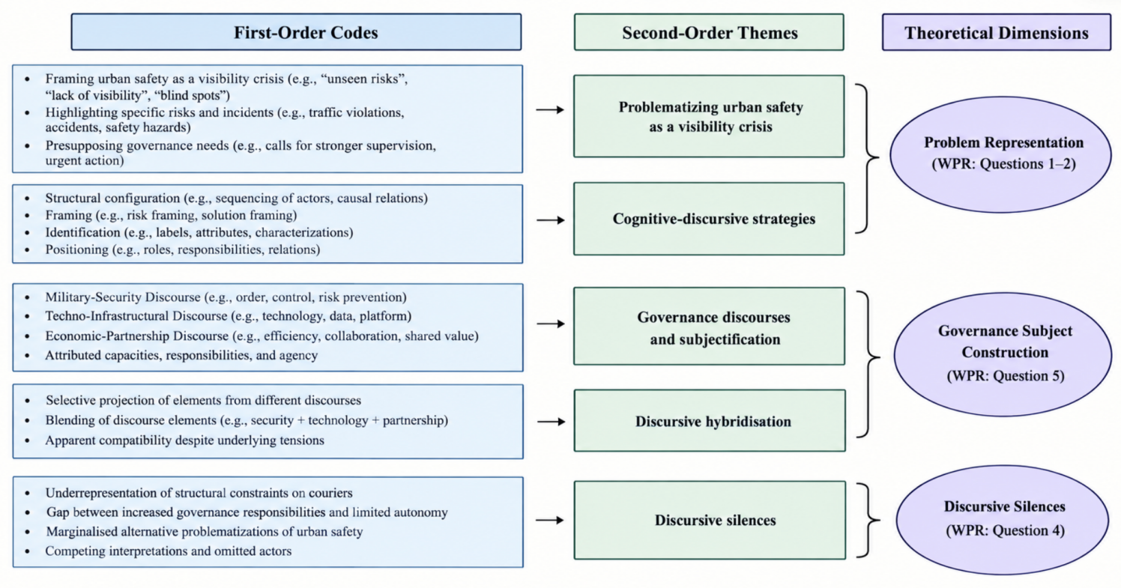
Figure: Coding structure

References
Corbin, J. and Strauss, A. (2015). Basics of Qualitative Research. Techniques and Procedures for Developing Grounded Theory, 4th edition. London: Sage.

